|  |
| --- |
| Software design |
| Library system |
| Version 1.0 |
| Prepared by class SE0715, Group 1  Nguyen Tuan Anh  Huynh Thi Hoa  …..  November 10, 2013 |

Contents

Revision history 4

1. Document description 5

2. SRS overview 5

2.1. List of system users 5

2.2. List of use cases 5

2.3. Use case diagram 5

2.3.1. Preliminary use case diagram 5

2.3.2. Use case detail diagrams 6

2.4. Activity diagrams of use case scenarios 7

2.4.1. Activity diagram for use case “Borrow Book” 7

2.4.2. Activity diagram for use case “Return Book” 8

2.4.1. Activity diagram for use case “Reserve Book” 8

3. Data model 9

3.1. Entity Relationship Diagram 9

3.2. Table details/Chi tiết các bảng 9

3.2.1. Table name: Borrower 9

3.2.2. Table name: Book 9

3.2.3. Table name: Copy 10

3.2.4. Table name: CirculatedCopy 10

3.2.5. Table name: Reservation 10

4. Class diagram (p.61 – p70) 11

4.1. List of classes in the Layers 11

4.2. Modeling the Class Behaviors - sequence diagrams ( p. 66, 77) 11

4.2.1. Sequence diagram for use case “Borrow Book” 11

4.2.2. Sequence diagram for use case “Return Book” 12

4.2.3. Sequence diagram for use case “Reserve Book” 13

5. User Interface Model Design (p. 70 – p.74) 13

5.1. User interface model design 13

5.2. Interface Flow Diagrams (p. 51) 13

# Revision history

|  |  |  |  |
| --- | --- | --- | --- |
| **Date** | **Authors** | **Modifications** | **Version** |
|  |  |  |  |
|  |  |  |  |
|  |  |  |  |
|  |  |  |  |
|  |  |  |  |

# Document description

This document describes OO solution version 1.0 for Library system. It is divided into the following sections:

* In the section 2 an overview of the Library system’s requirements will be provided, including list of system users, use cases, use case diagram, and activity diagrams that describes the most important use case scenarios.
* In the section 3 an E-R diagram and all tables of the Library system in detail will be presented.
* In the section 4 all classes organized in the layers and their behaviors (sequence diagrams) for the most important use cases will be presented.
* In the section 5 the most screen prototypes will be presented.

# SRS overview

## 2.1. List of system users

1. Librarian: The person is working in the Library room

2. Borrower: The person uses services of the Library system

## 2.2. List of use cases

1. Borrow Book(s)

2. Return Book(s)

3. Reserve Book

4. Register Book

5. Register Member

## 2.3. Use case diagram

### 2.3.1. Preliminary use case diagram

Library System

Librarian

Borrower

### 

### 2.3.2. Use case detail diagrams

#### 2.3.2.1. Use case “Borrow Book”

Librarian

uses

uses

extends

#### 2.3.2.1. Use case “Return Book”

Librarian

uses

uses

extends

#### 2.3.2.1. Use case “Reserve Book”

Librarian

uses

#### 2.3.2.1. Use case “Register Book” and “Register Member”

Librarian

uses

uses

extends

## 

## 2.4. Activity diagrams of use case scenarios

### 2.4.1. Activity diagram for use case “Borrow Book”

Get borrower code

No

Borrower existing?

Yes

No

Number of copies borrowed < 5?

Yes

Get copy Number

Copy existing?

No

Yes

Referenced or Borrowed

Copy type?

Available

Reserved by any other user or Borrower is not the first in reservation

Check reservations for this book?

Borrow (Update copy type & reservation status)

Not reserved by any other user or Borrower is the first in reservation

### 2.4.2. Activity diagram for use case “Return Book”

Get borrower code

Show borrower information and borrowed copies

Select copies returned

No

Returned date <= due date?

Calculate Fine Amount

Yes

Return (Update copy type)

### 2.4.1. Activity diagram for use case “Reserve Book”

Get borrower code

No

Borrower existing?

Yes

Yes

There is any reservation? existing?

No

Reserve

Yes

No

Yes

No

No

No any copy?

All copies are referenced?

Yes

There is any available copy?

Get book number to reserve

# Data model

## Entity Relationship Diagram

Borrower

Book

Copy

Reservation

CirculatedCopyy

Note: one-to-many

## Table details/Chi tiết các bảng

Note: Attribute with underline is Primary key

### Table name: Borrower

|  |  |  |  |
| --- | --- | --- | --- |
| **Field name** | **Type** | **Size** | **Note** |
| BorrowerNumber | Integer | 10 | Primary key |
| Name | String | 40 | Not null |
| Address | String | 40 | Allows null |
| Email | String | 40 | Allows null |
| Telephone | String | 40 | Allows null |

### Table name: Book

|  |  |  |  |
| --- | --- | --- | --- |
| **Field name** | **Type** | **Size** | **Note** |
| BookNumber | Integer | 10 | Primary key |
| Title | String | 40 | Not null |
| Publisher | String | 40 | Allows null |
| Author | String | 40 | Allows null |

### Table name: Copy

|  |  |  |  |
| --- | --- | --- | --- |
| **Field name** | **Type** | **Size** | **Note** |
| BookNumber | Integer | 10 | Foreign key, refers to Book table |
| CopyNumber | Integer | 10 | Primary key |
| SequenceNumber | Integer |  | sequence number for each copy of the same book |
| Type | Integer |  | 0: Available; 1: Borrowed; 2: Referenced |
| Price | Double |  | Allow null |

### Table name: CirculatedCopy

|  |  |  |  |
| --- | --- | --- | --- |
| **Field name** | **Type** | **Size** | **Note** |
| ID | Integer | 10 | Primary key |
| BorrowerNumber | Integer | 10 | Foreign key, refers to Borrower table |
| CopyNumber | Integer | 10 | Foreign key, refers to Copy table |
| BorrowDate | Date |  | Not null |
| DueDate | Date |  | Allow null |
| ReturnDate | Date |  | Allow null |
| FineAmount | Double |  | Allow null |

### Table name: Reservation

|  |  |  |  |
| --- | --- | --- | --- |
| **Field name** | **Type** | **Size** | **Note** |
| ID | Integer | 10 | Primary key |
| BorrowerNumber | Integer | 10 | Foreign key, refers to Borrower table |
| BookNumber | Integer | 10 | Foreign key, refers to Book table |
| Date | DateTime |  | Not null |
| Status | Integer |  | 0: Available; 1: Reserved; |

# Class diagram (p.61 – p70)

## List of classes in the Layers

Layer GUI

Layer DT

Book

BookGUI

BorrowerGUI

ReserGUI

ReturnGUI

BorrowGUI

MainFormGUI

Copy

Borrower

CirculatedCopy

Layer DA

Reservation

ReservationDA

CirculatedCopyDA

BorrowerDA

CopyDAO

BookDAO

Note: Allow to use

BL: Business logic DT: Data transfer

DA: Data access

Library Database

## Modeling the Class Behaviors - sequence diagrams ( p. 66, 77)

### Sequence diagram for use case “Borrow copy”

DisplayButtons(3)

checkCondition(borrowerNumber, copyNumber, out copy, out reservation)

DisplayButtons(2)

:ReservationDA

:CopyDA

:BorrowerDA

:BorrowGUI

:CirculatedCopyDA

View()

Check member

GetBorrower(borrowerNumber)

GetBorrowedCopies(borrowerNumber)

GetBorrowedCopies(borrowerNumber)

GetCopy(copyNumber)

GetFirstReservation(bookNumber)

Borrow

Check condition

Insert(circulatedCopy)

Update(reservation)

Update(copy)

borrow(circulatedCopy, copy, reservation)

View()

DisplayButtons(1)

### Sequence diagram for use case “Return copy”

GetCopy(copyNumber)

GetBorrowedCopies(borrowerNumber)

GetBorrowedCopies(borrowerNumber)

Calculate Fine Amount

Return

Check member

Update(copy)

Update(circulatedCopy)

Return(circulatedCopy)

DisplayButtons(1)

View()

GetBorrower(borrowerNumber)

:CirculatedCopyDA

:BorrowerDA

:CopyDA

:ReturnGUI

DisplayButtons(3)

DisplayButtons(2)

View()

### Sequence diagram for use case “Reserve Book”

:CopyDA

:ReserveDA

:BorrowerDA

:ReserveGUI

GetBorrower(borrowerNumber)

DisplayButtons(3)

View()

DisplayButtons(1)

Check member

View()

SelectDS(borrowerNumber, ‘R’)

DisplayButtons(2)

checkCondition(borrowerNumber, bookNumber)

SelectDS(borrowerNumber, ‘R’)

Check condition

SelectDS(bookNumber)

Reserve

Insert(reservation)

SelectDS(borrowerNumber, ‘R’)

# User Interface Model Design (p. 70 – p.74)

## User interface model design

### 51.1. Screen “Register books”

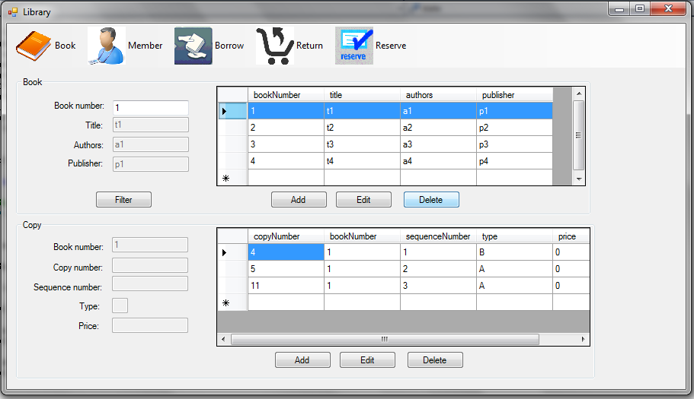

### 51.2. Screen “Register members”

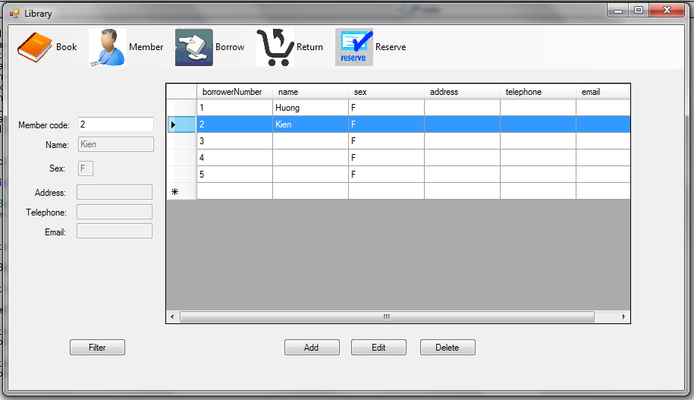

### 51.3. Screen “Borrow books”

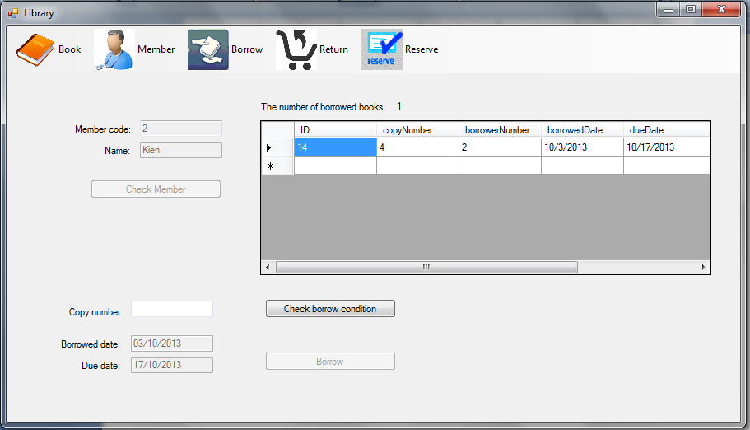

### 51.4. Screen “Return books”

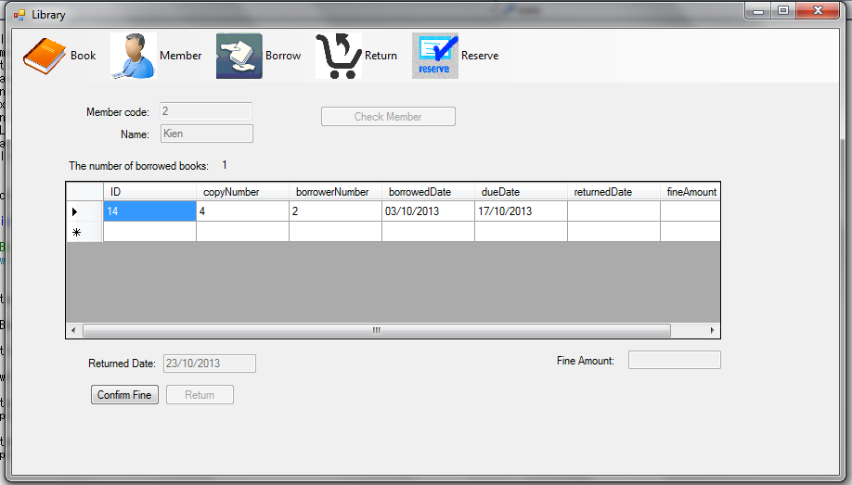

### 51.5. Screen “Reserve books”

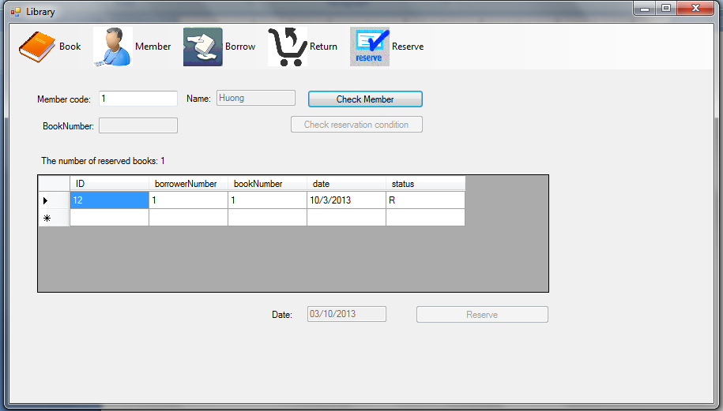

## Interface Flow Diagrams (p. 51)

Main form (main menu)

Return books

Reserve books

Borrow books

Register books

Register members

[Click Book]

[Click Member]

[Click Reserve]

[Click Borrow]

[Click Return]